API Integration Platform

Task Submission Document

Student Information

Name
Mathivadhana V

Project Title
API Integration Platform V2

GitHub Repository
https://github.com/malarmathi23015-lgtm/API-integration

Project Overview
API Integration Platform V2 is an advanced Python-based application that integrates multiple real-time APIs including Weather, Cryptocurrency, and News services into a unified monitoring platform.
The system performs:
- Real-time API data fetching
- JSON data parsing
- AI-based sentiment analysis
- Cryptocurrency trend detection
- SQLite database storage
- Intelligent alert generation
The project follows a modular and scalable architecture suitable for real-world software development.

Objectives
The main objectives of this project are:
- Learn API integration using Python
- Process JSON responses from APIs
- Implement modular project architecture
- Store data using SQLite database
- Perform sentiment analysis using NLP
- Create an expandable monitoring platform

Technologies Used
Technology | Purpose
Python | Core programming
Requests | API communication
SQLite3 | Database management
TextBlob | Sentiment analysis
Pandas | Data processing
dotenv | Environment variable management
Git & GitHub | Version control

APIs Used

Weather API
OpenWeatherMap API
Used for:
- Temperature monitoring
- Humidity tracking
- Weather condition analysis

Cryptocurrency API
CoinGecko API
Used for:
- Bitcoin price tracking
- Ethereum price tracking
- Dogecoin monitoring

News API
NewsAPI
Used for:
- Real-time news retrieval
- Technology news monitoring
- AI news analysis

Project Features

Weather Monitoring
- Real-time weather updates
- City-based weather search
- Humidity and condition tracking

Cryptocurrency Monitoring
- Live crypto price tracking
- Trend detection engine
- Market alert system

News Aggregation
- Real-time news fetching
- AI sentiment analysis
- News storage system

Database Integration
- SQLite database support
- News history storage
- Sentiment record management

Alert System
- Crypto crash detection
- Intelligent monitoring alerts

Project Structure
API integration/
│
├── main.py
├── config.py
├── requirements.txt
├── README.md
│
├── api/
├── ai/
├── database/
├── dashboard/
├── alerts/
├── services/
├── utils/
└── data/

Important Code Snippets

Weather API Integration
import requests

response = requests.get(url)
data = response.json()

Sentiment Analysis
from textblob import TextBlob

sentiment = TextBlob(text).sentiment.polarity

SQLite Database Connection
import sqlite3

connection = sqlite3.connect("data/app.db")

Screenshots

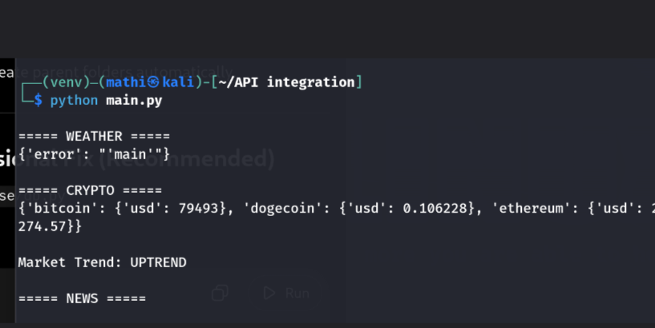

Example Output
===== WEATHER =====
{'city': 'Chennai', 'temperature': 34}

===== CRYPTO =====
{'bitcoin': {'usd': 64000}}

Market Trend: UPTREND

===== NEWS =====
Title: OpenAI launches new AI model
Sentiment: Positive

Challenges Faced
- Managing Python virtual environments
- Handling API key configuration
- Fixing SQLite database path issues
- Managing package dependencies in Kali Linux

Solutions Implemented
- Created isolated virtual environment
- Used dotenv for secure API key storage
- Implemented modular project architecture
- Added database initialization handling

Learning Outcomes
Through this project, the following concepts were learned:
- API Integration
- JSON Parsing
- Database Management
- Sentiment Analysis
- Modular Python Development
- GitHub Project Management
- Real-Time Monitoring Systems

Future Enhancements
Planned future improvements include:
- Dashboard UI
- Dark mode support
- Real-time analytics graphs
- Telegram alert integration
- FastAPI backend
- Android application using Kivy
- AI-based market prediction

Conclusion
The API Integration Platform V2 project successfully demonstrates the implementation of multiple real-time APIs combined with AI sentiment analysis and database storage in a modular Python application.
The project provides a strong foundation for advanced monitoring systems, AI dashboards, and future scalable applications.

Repository Link
https://github.com/malarmathi23015-lgtm/API-integration

Author
Mathivadhana V

